

American International University- Bangladesh

CSC 3222: Web Technologies

CO1.1 and CO2.1 Evaluation

Project Report

Fall 19-20

**Project Title:** **Rental Management System.**

**Section**: **F**

|  |  |
| --- | --- |
| Student Name | Student Id |
| 1. Hossain, Muntasir | **18-36421-1** |
| 2. Banik, Pryam | **18-37571-1** |
|  |  |
|  |  |

**Introduction:**

🡺 In our present world, our life mainly depends on technology and software, people now-a-days wants to accomplish their daily basis works in short time with efficiently.

So to reduce people’s time and energy we are doing this project, so that they can be beneficial through our work. Our system aims at enabling efficient rental management for Web based apllication.

\*\***Background Study**

<https://www.onlinebuysale.com/>

<https://www.bproperty.com/>

Took some design idea and implement into my application.

Requirement Analysis:

1. User Category 1 : Car Dealer.
2. User Category 2 : House/Room Vendor.

There are 2-types of Users here. They are:

* **ADMIN.**
* **SELLER.**

1. Feature List:

In this project the **“ADMIN”** has the following features:

* Log In
* Sign Up
* Edit Profile
* Maintain(Rules & Regulations)

In this project the **“SELLER”** has the following features:

* Log In
* Sign Up
* Edit Profile
* Maintain Ads

Design:

Entity diagram of our project, given below;

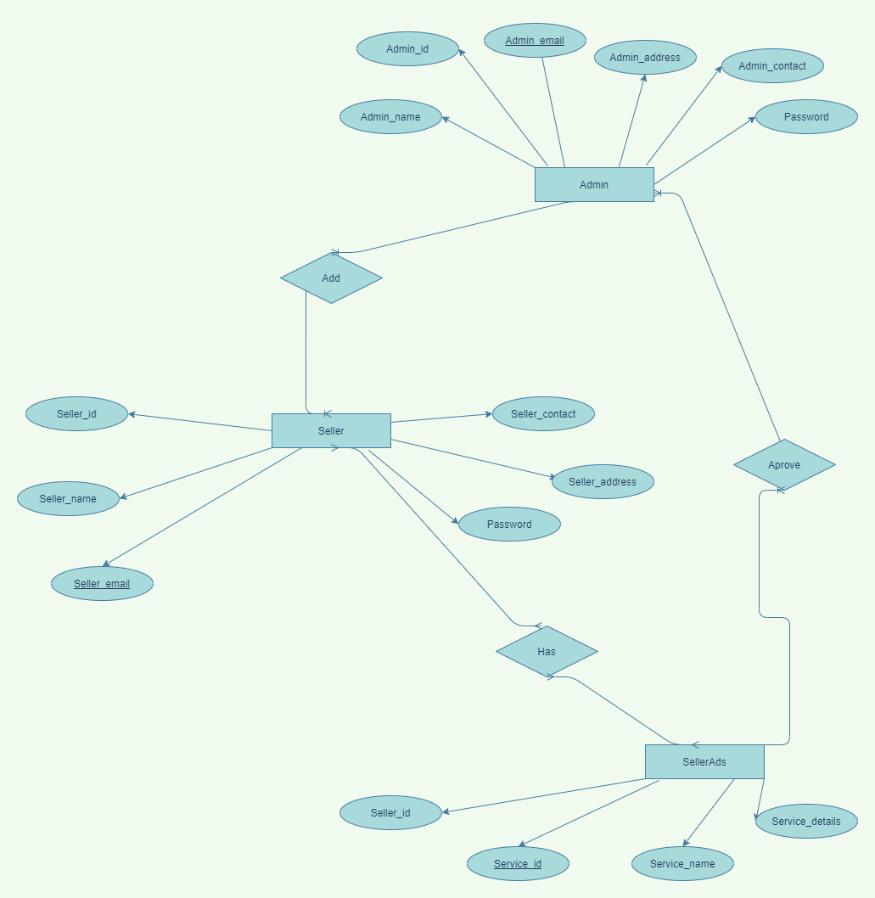

**Tools Used:**

**To develop this project, we have used the following:**

**• Visual Studio Code(Editor).**

**• Xampp Control Panel(Server).**

**• Chrome(Browser).**

**• https://mockflow.com/**

**System Images against the Specification:**

Screen shots of some GUIs (Midterm project) and write a very small description (Maximum 40 words) for each of the GUIs.

**1.** **HomePage :**

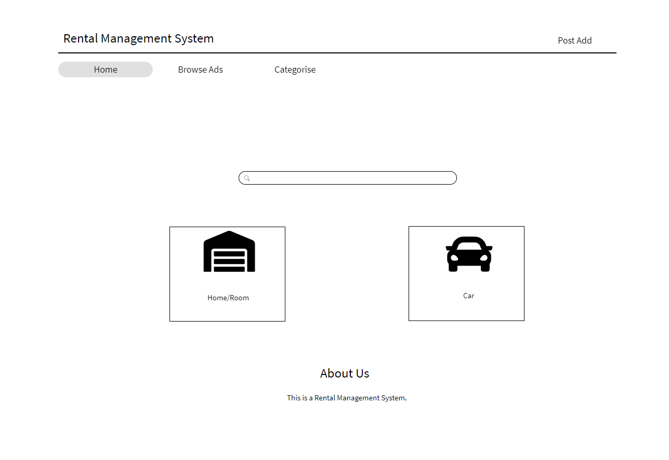

**This is the Homepage of our Rental Management Project, where you will able to see some features like BrowseAds, Categorise, a Search Option, Home/Room and Car rental service options, lastly, there is an option which is About Us option menas where the some legal information might display about our project**.

**2. BrowseAds and Categorise :**

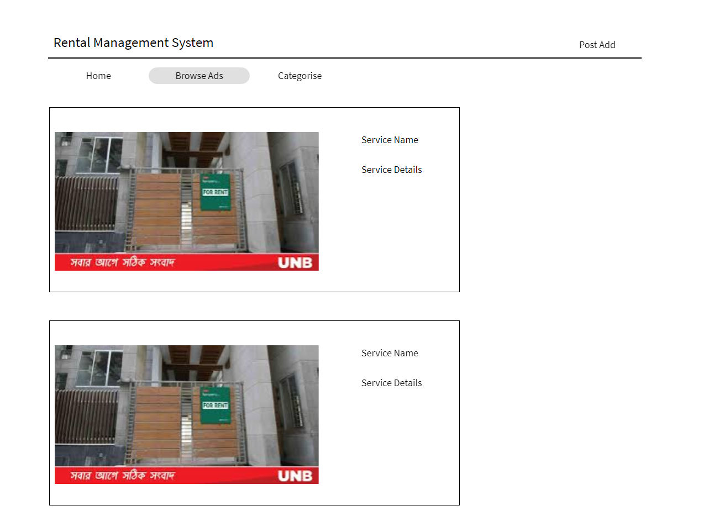

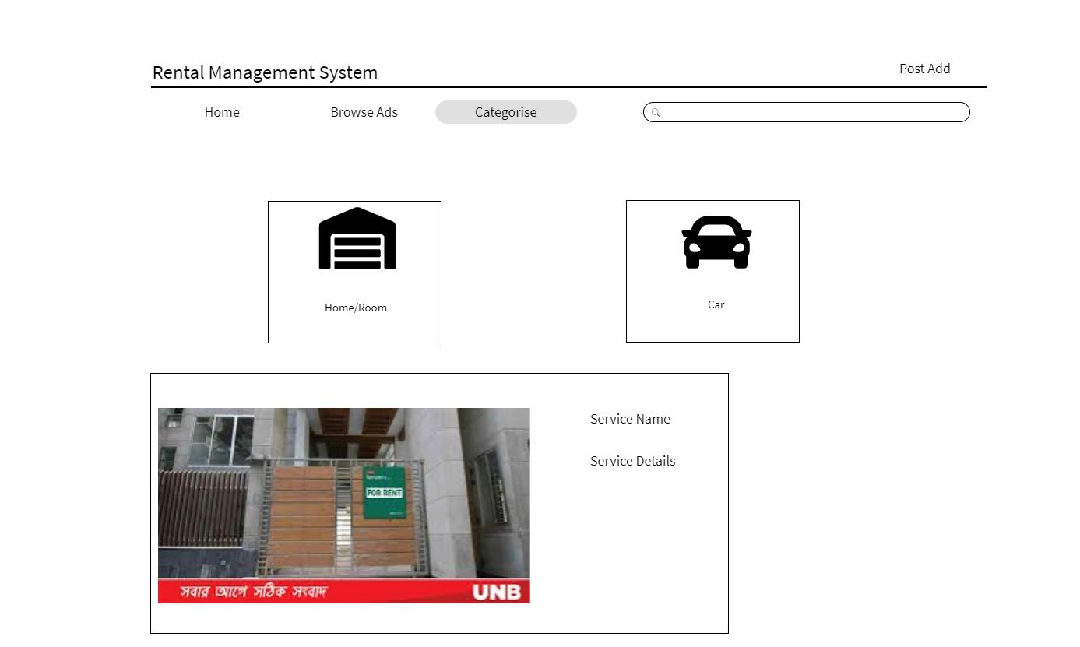

This two features are part of our Homepage, which will present the service regarding information that we will provide.

**3. SignUp Page:**

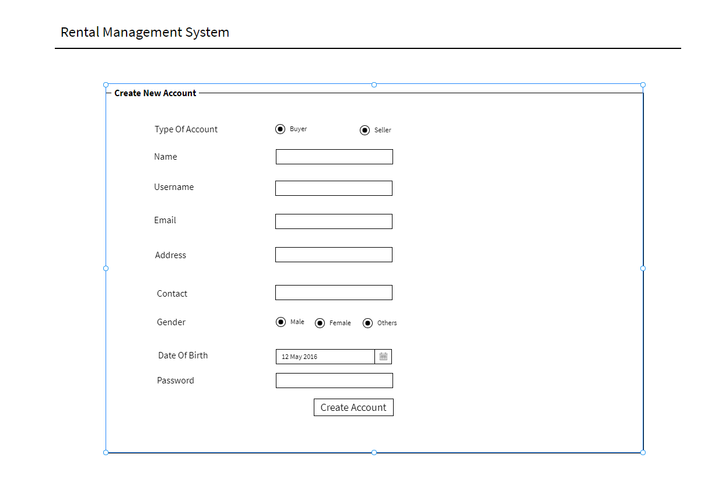

**Now, we would like to introduce with our SignUp page where many informations are visible for our users. This page will shown up to a new user, who will take our service system by creating an account in our website for the first time.**

**5. Login Page:**

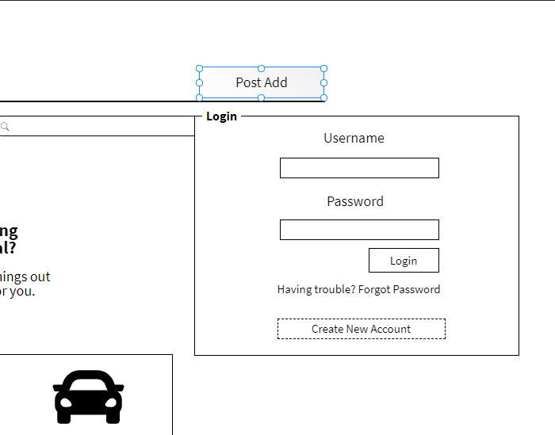

**Lastly, we now present our ending GUI feature for our project which is our Login page. This page will be visible for every users, everytime when they are going to us our system after signing in our site. In the page we put a field for username and password and others according to the above picture.**

Impact of this Project:

Describe the increasing importance of your project on modern society and environment.

How will people be benefitted from your project?

This online rental solution is fully functional and flexible. It is very easy to use. It saves a lot of time and money .The software acts as an office that is open 24/7. It will increases the efficiency of the management at offering quality services to the customers.

Limitations and Possible Future Improvements:

There are some limitation like here we only include Home/Room and Car for Rent.

In future we will implement Apartment or any Vehicle for sale.

Also we will include Buyer and Digital payment for our system.

|  |  |  |  |  |  |
| --- | --- | --- | --- | --- | --- |
| CO1.1 and CO2.1 Evaluation: Project Report Evaluation | | | | | |
| Project Proposal  (5) | Background  Study  (5) | Requirement Analysis  (5) | Entity  Diagram  (5) | System Images  against the  Specification (5) | Total (25) |
|  |  |  |  |  |  |
|  | | | | | |